Report for Homework 1 – ECE650
yz803

Section 1: Requirements and summary of development.
The main purpose of this assignment is to design the malloc function and the corresponding free function of two strategies in C language. The Linux environment is Ubuntu 18.04.6 LTS during the development, and Valgrind is used to solve memory leaks, and GDB is used for debugging. The development process is mainly composed of design and development, testing and debugging, results and analysis.

Section 2: Design, implementation and test
As for the design, in terms of data structure, I designed two sets of linked lists at the beginning, one for occupied and one for free, but in the process of writing, I found that the linked list for occupation was useless, so I deleted it. For the data structure of free, I use the structure of a doubly link list, and include the value of size in this block. In the final debug, I also added is_free to judge whether the area has been freed. In terms of algorithms, the details are shown in the graph
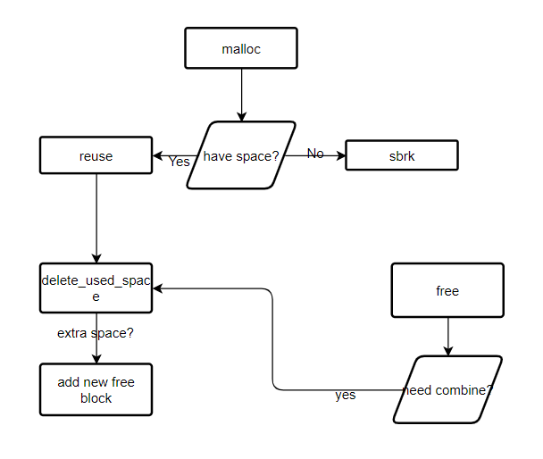
The algorithm for malloc and free
In terms of details, FF is short for the first fit and BF is short for the best fit. For FF, searching for the allocated space should find the first free block that can be stored through the doubly linked list, while for BF, it should traverse all the free space, and select the most suitable block to allocate.
For testing, first test each function, and then debug through the test files in the provided homework1-kit after there are basically no problems.

Section 3: Performance Results & Analysis
Compare the performance of the 2 implementations on the 3 different provided benchmarks. Explain the reason of the differences. Draw your conclusions on possible guidelines for choosing an implementation. Please report data in clearly understandable way. Charts are better than tables.
Here are the results of the implementation.
 | first-fit |  | best-fit
 | execution time /s | fragmentation | execution time /s | fragmentation
small | 6.249543 | 0.673934 | 1.330858 | 0.863673
equal | 15.230872 | 0.999911 | 15.278247 | 0.999911
large | 50.885794 | 0.837558 | 51.07491 | 0.913757
For small_size_allocate, FF takes longer than BF, and the value of fragmentation is relatively small. This is because best fit is more suitable for space utilization, and choosing a more suitable space for allocation is beneficial to improve space utilization. In terms of time, since first-fit is always allocated at the first suitable place, there may be many free linked list structures for composite and split operations, which is a waste of time.
For equal_size_allocate, the time taken by the two is similar, and the fragmentation is the same. This is because in the equal test, all space allocations are of equal length, which causes FF to always select the first free block, while BF can find that the first one meets the requirements when searching for the most suitable space, and jump out of the loop , so the time consumption is the same as that of FF.
For large_size_allocate, BF takes longer than FF, because BF needs to traverse the entire linked list to find the most suitable allocation space. Since there is no fixed-length allocation system such as equal, time cannot be saved, resulting in a longer time spent.
To sum up, since time is more precious and the storage media is pretty cheap, although BF can save space, I prefer the FF strategy to save up time.

